Wireless Security

Wireless Layer 2 Technology

Weight: 1.15% Marks:  /42

Student Name: Ahmed Almass

Student ID: 651096 Date:

# Introduction

In this lab, you will focus on collecting and reviewing wireless traffic with various types of architectures.

Lab activities in this course will be marked in class. You must bring this document to every lab in the module. Each activity must be completed and then marked by the instructor before you move on to the next. To avoid a mark of zero for an activity, contact the instructor immediately if you cannot complete the activity for any reason, or if the activity was left unmarked by the instructor.

# Equipment

* Laptop with wireless capabilities
* Topology
* Wireshark with Npcap

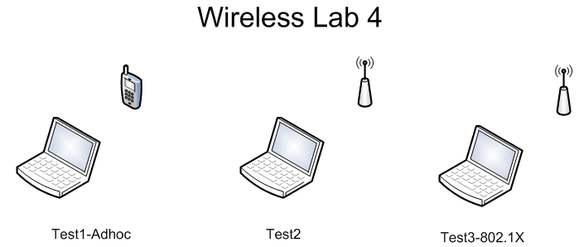

© 2017, Southern Alberta Institute of Technology

# Lab Setup

Before you begin the lab activities, perform the steps below to set up your computer.

1. Set up a Windows workstation with the following parameters:

* Wireless network adapter
* Latest version of Wireshark with Npcap

# Activity 4.1: Verifying Setup of the WiFi Radiator

1. Identify and set up the AP radiators (Test1-Adhoc, Test2, Test3-802.1X). (2 points)
2. Verify that Wireshark can collect wireless traffic. (2 points)
3. Coordinate with your instructor during each radiator collection type. (2 points)

**Instructor sign-off:** __________________ (5 points)

# Activity 4.2: Collecting Data

1. Collect and save Test1-Adhoc. (2 points)
2. Collect and save Test2. (2 points)
3. Collect and save Test3-802.1X. (2 points)

**Instructor sign-off:** __________________ (5 points)

# Activity 4.3: Performing Analysis

1. Analyze packet framing on wireless networks to understand the 802.11 header format and fields. Insert screen shots showing information for each type. (2 points)
   1. Test1-Adhoc

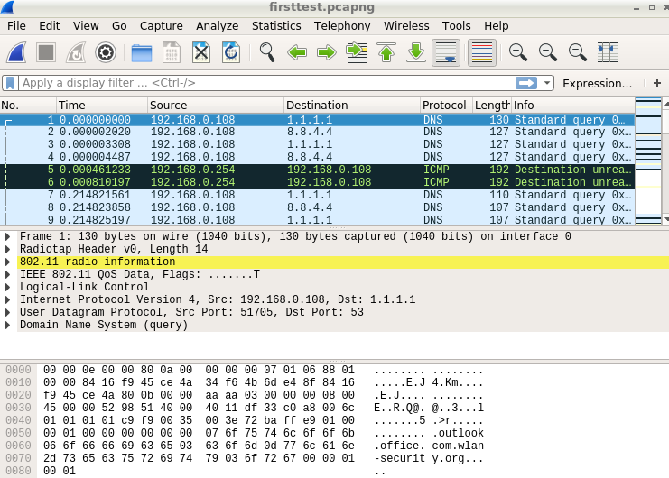

* 1. 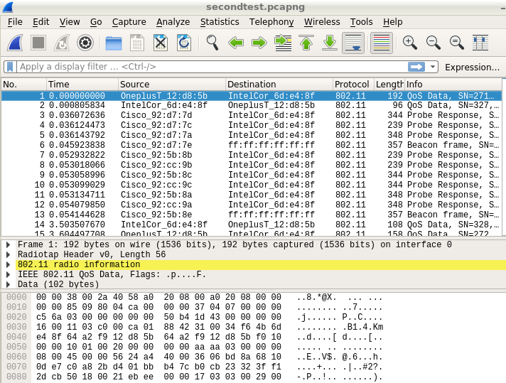Test2

1. Analyze the 802.11 address field ordering and behaviour. Insert screen shots showing information for each type. (2 points)
   1. Test1-Adhoc

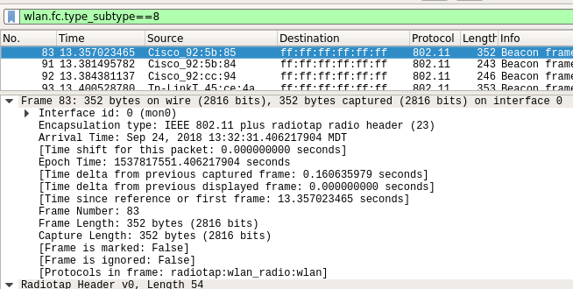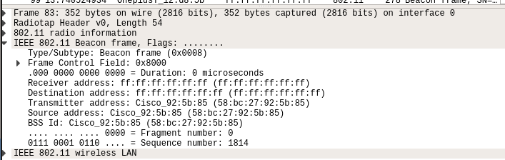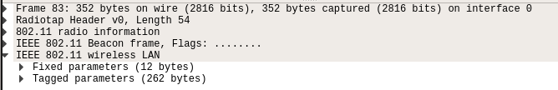

* 1. Test2

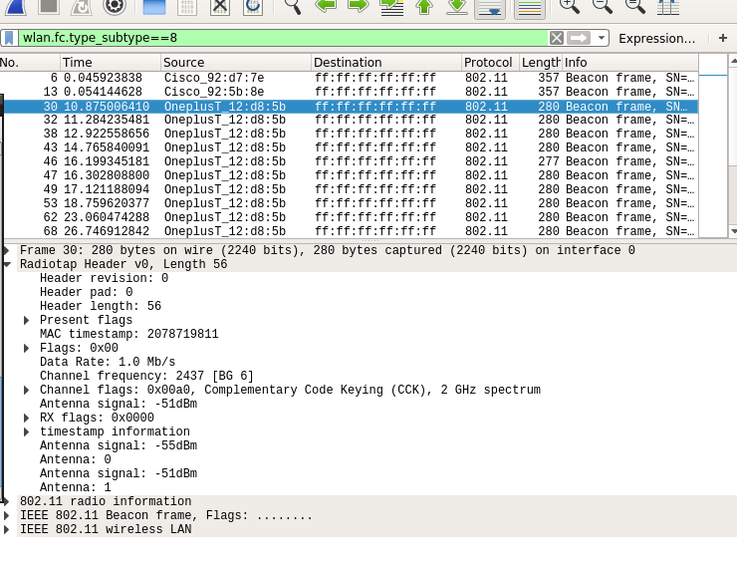

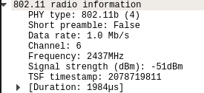

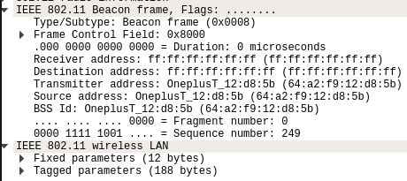

1. Analyze the operation and behaviour of IEEE 802.1X authentication, and insert a screen shot showing information for this type. (2 points)

n/a

**Instructor sign-off:** __________________ (5 points)

# Activity 4.4: Summary Analysis

Write a short paragraph summarizing your analysis of the data you recorded. (2 points)

________________________________________

_________________________________________________________________________

_________________________________________________________________________

Does the information you obtained above support what you learned during the lecture? Explain. (2 points)

_________________________________________________________________________

_________________________________________________________________________

**Instructor sign-off:** __________________ (5 points)

## 